PRIYANSHI VARSHNEY

500119447

BATCH 2

R2142230042

EXPERIMENT 7

**Title:  Use of Inbuilt functions and relational algebra operation**

**Objective:**To understand the use of inbuilt function and relational algebra with sql query.

      Write and execute the following queries using the Relational Algebra on the COMPANY  database schema.

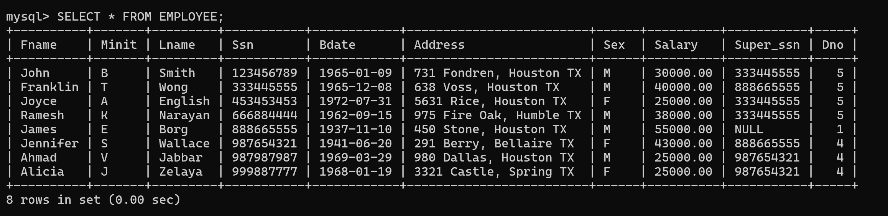

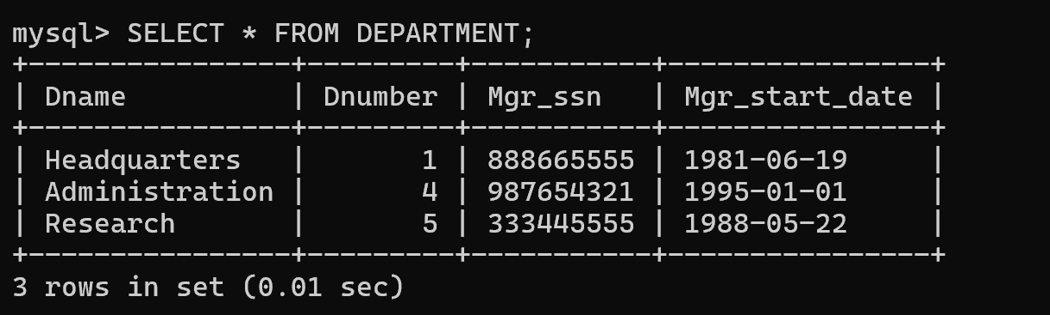

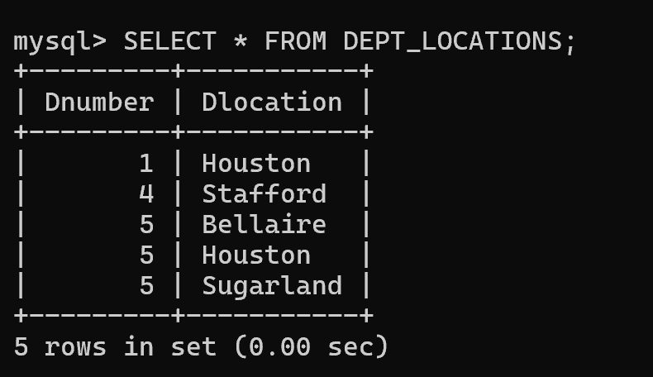

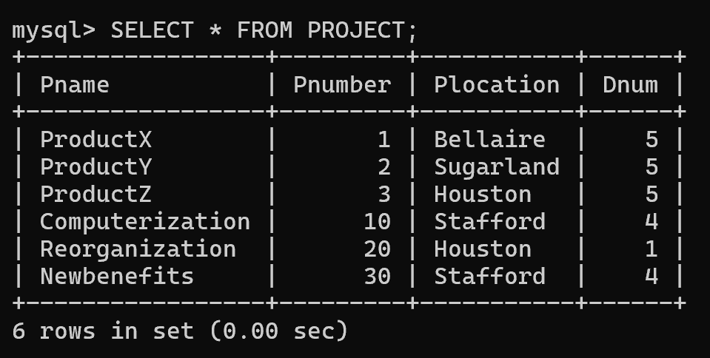

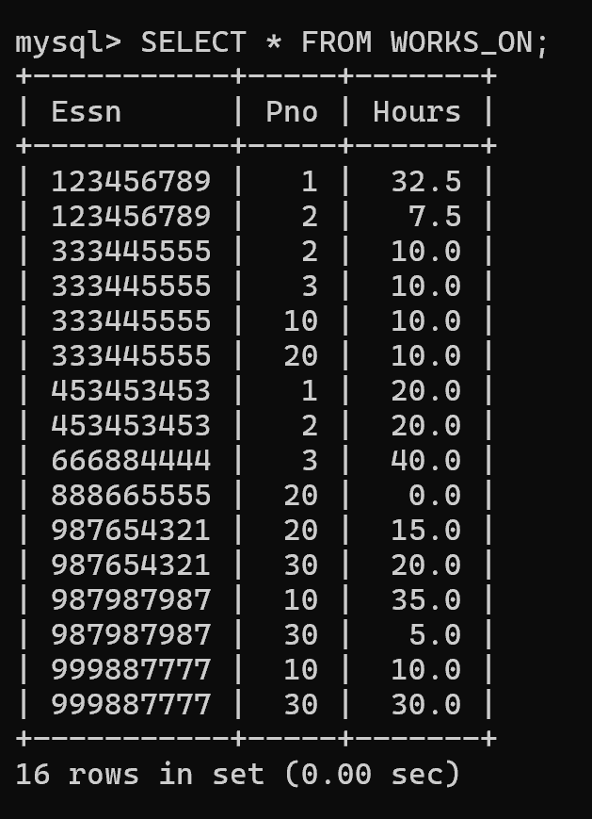

1. Retrieve the names of all employees in department 5 who work more than 10 hours per week on the ‘ProductX’ project.

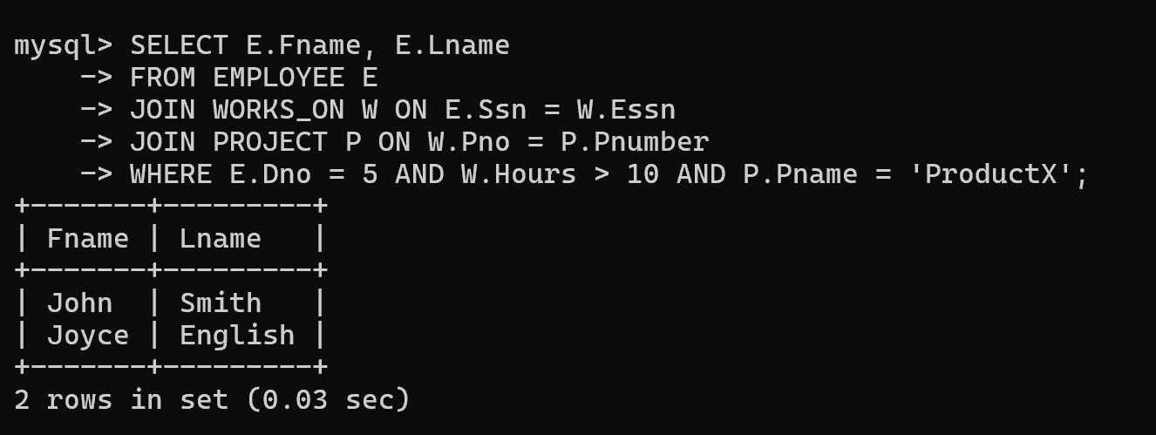

1. List the names of all employees who have a dependent with the same first name as themselves.

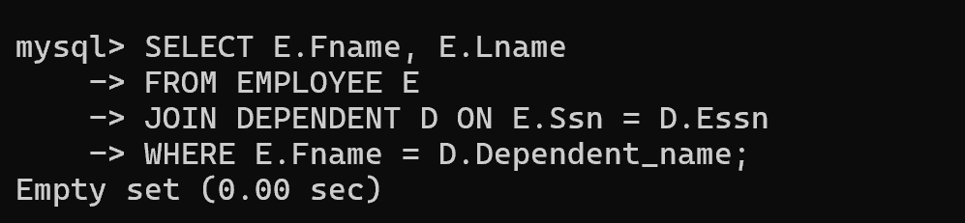

1. Find the names of employees who are directly supervised by ‘Franklin Wong’.

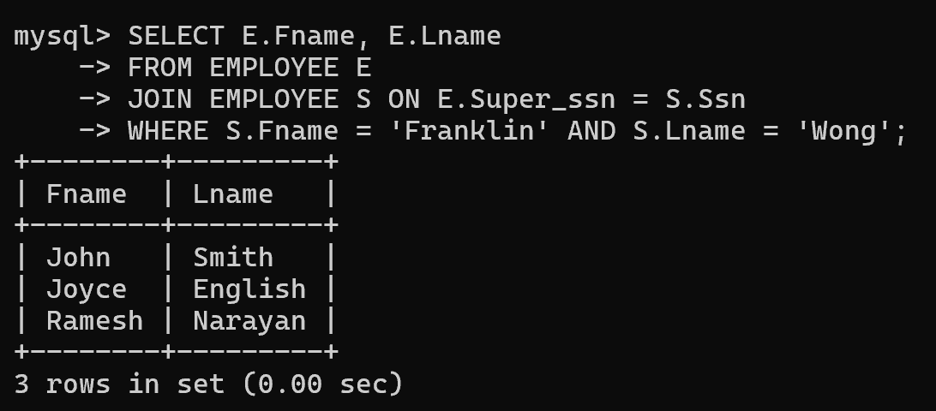

1. Retrieve the names of employees who work on every project.

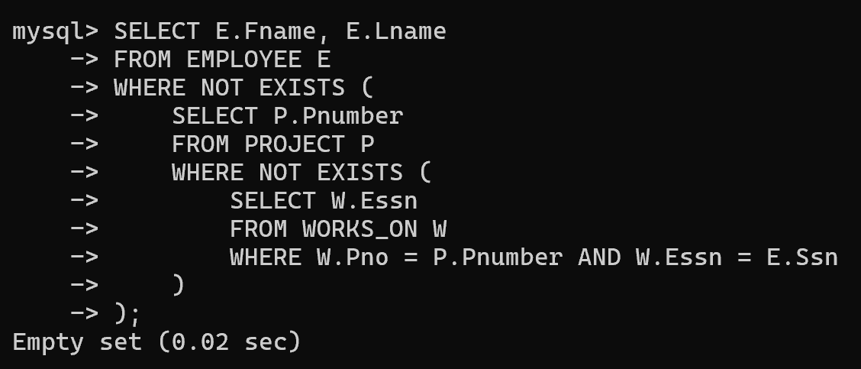

1. Retrieve the names of employees who do not work on any project.

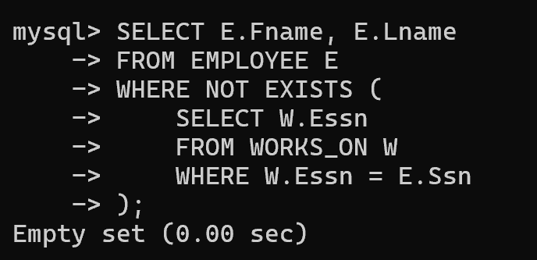

1. Retrieve the names and addresses of all employees who work on at least one project located in Houston but whose department has no location in Houston.

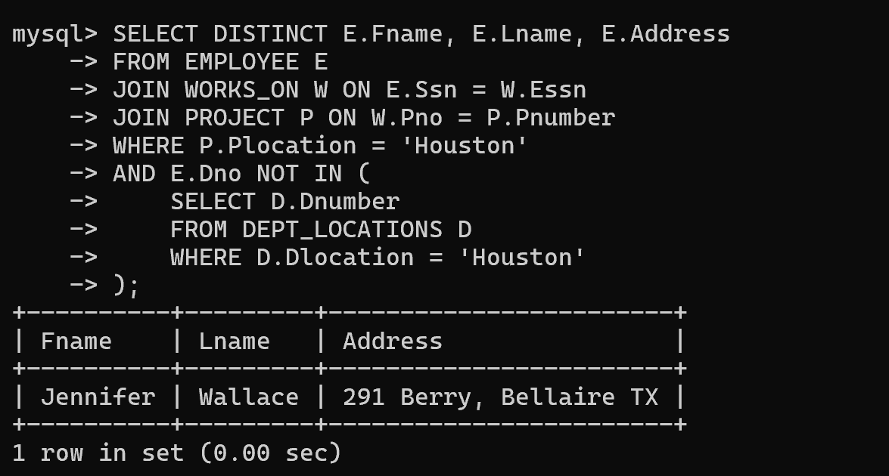

1. Retrieve the last names of all department managers who have no dependents.

